Jira Project

Find the screenshot of, Epic, User stories, Sub tasks

Reports, Release plan, Backlog & Scrum Board

Timeline –

5 epics

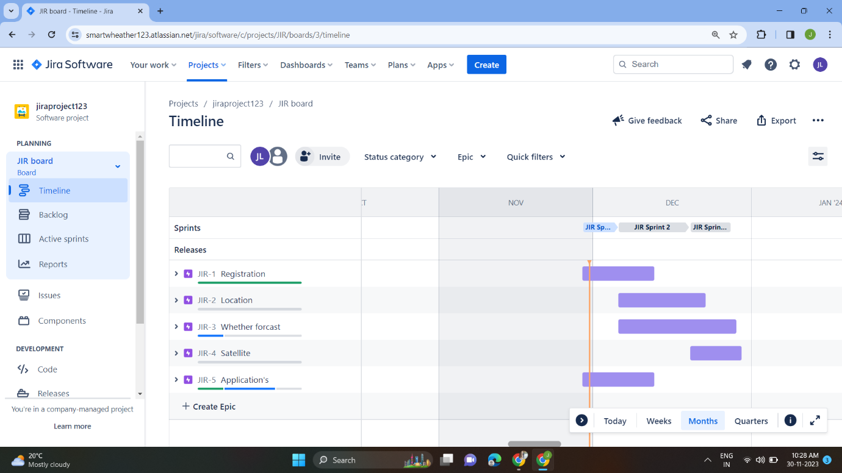

Back Log-

3 sprint & user stories

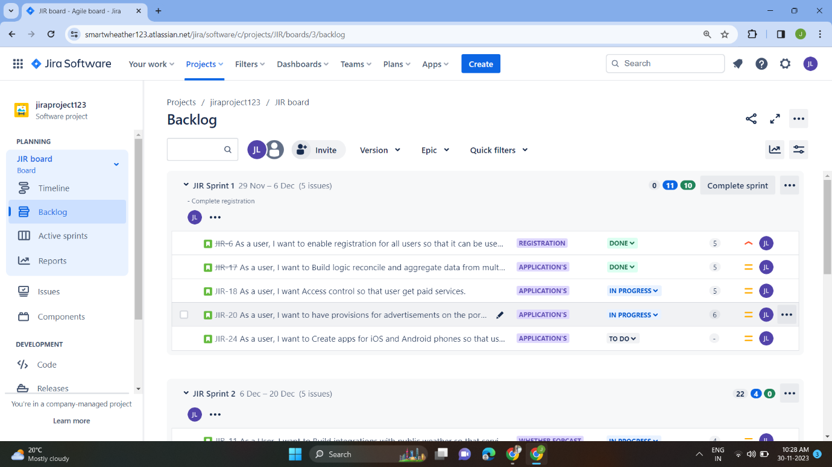

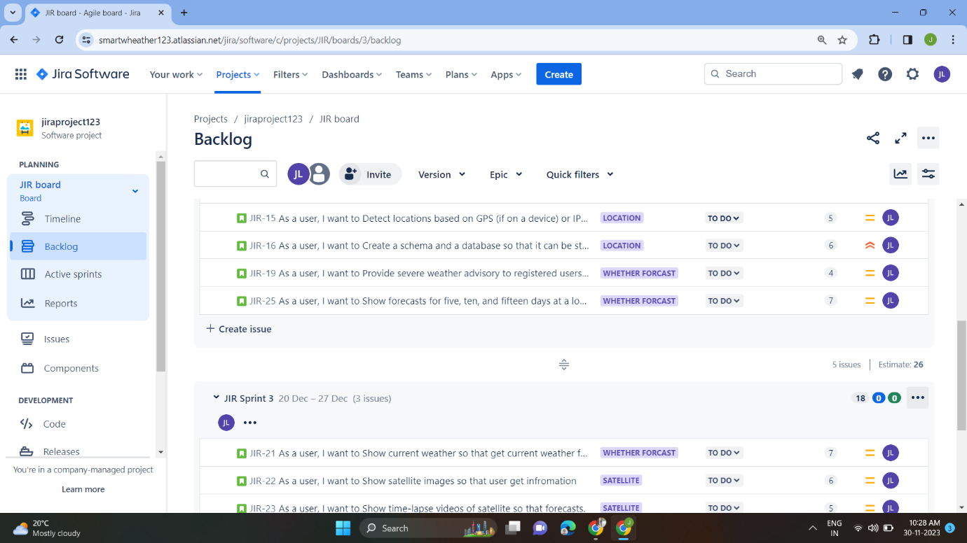

Sprint- episc & stories are done ,in progress % to do

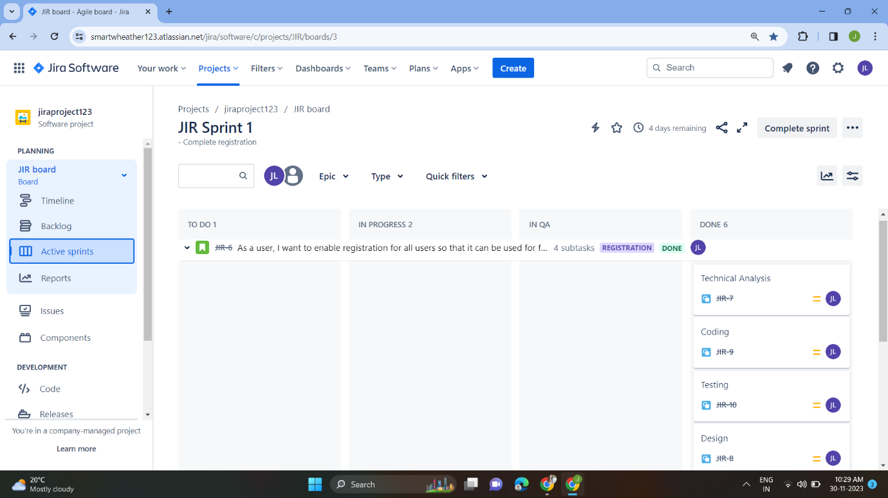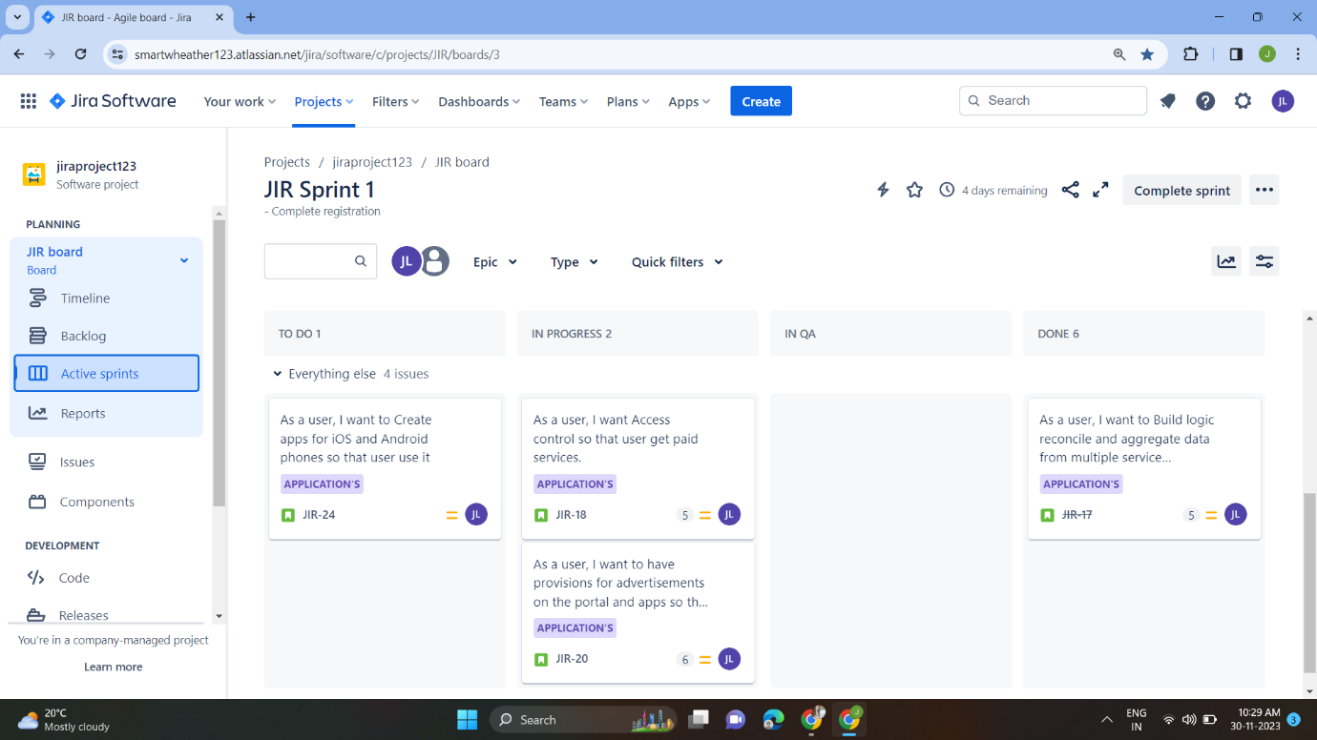

Sprint Reports

